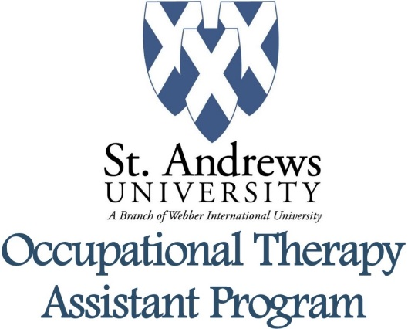
Personal Statement & Supplementary Essay
Using your own words, create a 500 – 1000 word essay and personal statement responding to the question: how have the experiences in your life shaped your choice to pursue a career in the field of occupational therapy?

