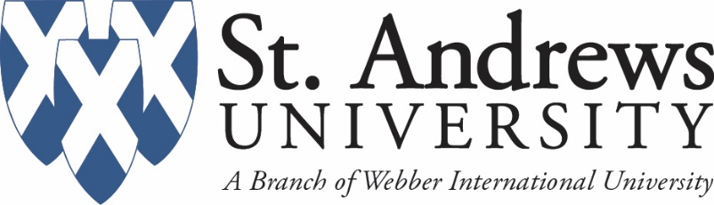

**Parent & Family Weekend**

**Thursday, October 6th**

6:00 pm Laurinburg after 5 on Main Street-no cost to attend

* Too Much Sylvia Band
  + Beach, Motown, Funky70’s, Retro 80’s
* Food Trucks and Games

**Friday, October 7th**

TBA Woman’s Soccer against Union College

TBA Men’s Soccer against Union College

5:00-6:00 pm President’s Welcome Reception in Avinger Terrace

* Final Agenda distributed
* Meet the Department Chairs and Faculty

6:30 pm Volleyball Match in PE against Brenau University

**Saturday, October 8th Black & Blue Day**

9:00 am-4:00 pm John Blue Cotton Festival

* https://www.johnbluefestival.com/homepage

10:30 am Bookstore Open

11:30-1:00 pm Tailgate Party with Staff, Faculty and Students at Football Field

* $8 a person and you pay at event
* Grab a picture with your family

11:00 am Volleyball Tri-Match against Truett-McConnell College

11:00 am Baseball

1:00 pm Football Game against Union College

* $5 to enter game-pay at entrance or

online at: <https://www.sauknights.com/tickets>

* Bring tent and chairs to tailgate in parking lot
* Bring chair to game

3:00 pm Volleyball Tri-Match in PE against Carolina University

**Sunday, October 9th**

10:30 am Farewell Bruch at Railroad Bar & Grill on Main Street

* 10% Discount-mention St. Andrews to your server